**Tasty Pizza Store Data Analysis**

**Creating a new database named Pizza DB for our data.**

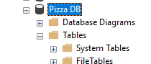

**Imported data from the csv file to Microsoft SQL server.**

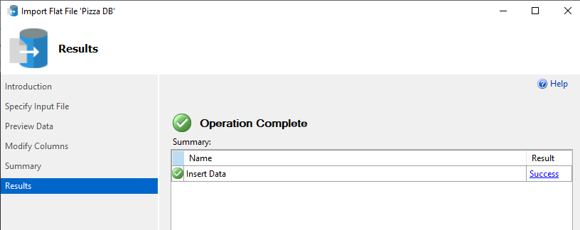

**Checking the data in our table**

SELECT * FROM pizza_sales

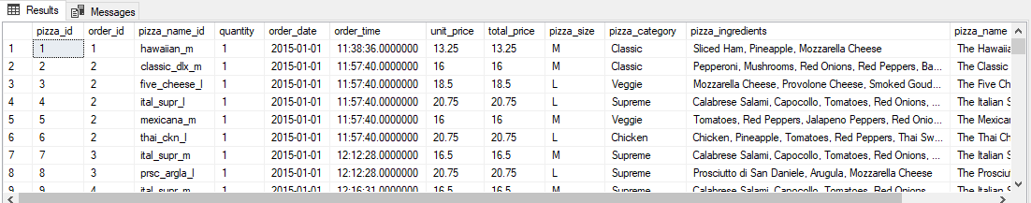

**KPIs**

**Total Revenue**

SELECT ROUND(SUM(total_price), 2) AS Total_Revenue

FROM pizza_sales

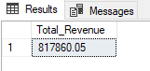

**Average Order Value**

SELECT ROUND(SUM(total_price)/COUNT(DISTINCT(order_id)) ,2) AS Average_order_value

FROM pizza_sales

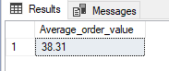

**Total Pizzas Sold**

SELECT SUM(quantity) AS Total_pizzas_sold

FROM pizza_sales

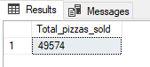

**Total Orders**

SELECT COUNT(DISTINCT(order_id)) AS Total_orders

FROM pizza_sales

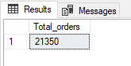

**Average number of pizzas per order**

SELECT CAST(CAST(SUM(quantity) AS DECIMAL(10,2))/

CAST(COUNT(DISTINCT(order_id)) AS DECIMAL(10,2)) AS DECIMAL(10,2))

AS Average_Pizzas_Per_Order

FROM pizza_sales

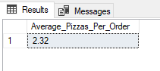

**Daily Trend for total orders**

SELECT DATENAME(DW, order_date) AS Order_day,

COUNT(DISTINCT order_id) AS Total_orders

FROM pizza_sales

GROUP BY DATENAME(DW, order_date)

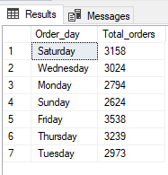

**Monthly Trend for total orders**

SELECT DATENAME(MONTH, order_date) AS Months,

COUNT(DISTINCT order_id) AS Total_orders

FROM pizza_sales

GROUP BY DATENAME(MONTH, order_date)

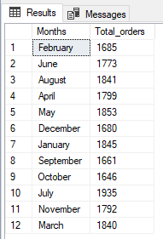

**Sales by Pizza Category**

SELECT pizza_category, CAST(SUM(total_price) AS DECIMAL(10,2)) as Revenue,

CAST(SUM(total_price) * 100 / (SELECT SUM(total_price) from pizza_sales) AS DECIMAL(10,2)) AS pct_share_in_revenue

FROM pizza_sales

GROUP BY pizza_category  
ORDER BY pct_share_in_revenue DESC

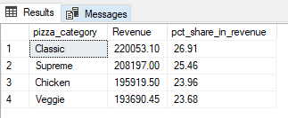

**Sales by Pizza Size**

SELECT pizza_size, CAST(SUM(total_price) AS DECIMAL(10,2)) as Revenue,

CAST(SUM(total_price) * 100 / (SELECT SUM(total_price) from pizza_sales) AS DECIMAL(10,2)) AS pct_share_in_revenue

FROM pizza_sales

GROUP BY pizza_size

ORDER BY pct_share_in_revenue DESC

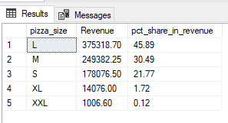

**Units sold by Pizza Category**

SELECT pizza_category, SUM(quantity) as Total_Units_Sold

FROM pizza_sales

GROUP BY pizza_category

ORDER BY Total_Units_Sold DESC

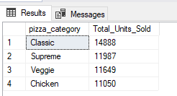

**Top 5 Pizzas by Revenue**

SELECT TOP 5 pizza_name, SUM(total_price) AS Revenue

FROM pizza_sales

GROUP BY pizza_name

ORDER BY Revenue DESC

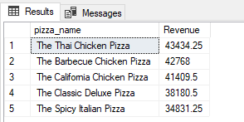

**Bottom 5 Pizzas by Revenue**

SELECT TOP 5 pizza_name, SUM(total_price) AS Revenue

FROM pizza_sales

GROUP BY pizza_name

ORDER BY Revenue ASC

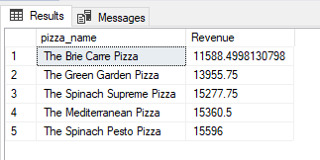

**Top 5 Pizzas sold by units sold**

SELECT TOP 5 pizza_name, SUM(quantity) AS Orders

FROM pizza_sales

GROUP BY pizza_name

ORDER BY Orders DESC

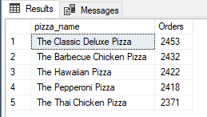

**Bottom 5 Pizzas sold by units sold**

SELECT TOP 5 pizza_name, SUM(quantity) AS Orders

FROM pizza_sales

GROUP BY pizza_name

ORDER BY Orders ASC

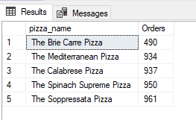

**Top 5 Pizzas sold by total orders**

SELECT TOP 5 pizza_name, COUNT(DISTINCT(order_id)) AS Orders

FROM pizza_sales

GROUP BY pizza_name

ORDER BY Orders DESC

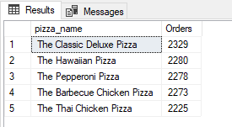

**Bottom 5 Pizzas sold by total orders**

SELECT TOP 5 pizza_name, COUNT(DISTINCT(order_id)) AS Orders

FROM pizza_sales

GROUP BY pizza_name

ORDER BY Orders ASC

